Recommend moving equip chip pulse carver routing (highlighted diffpairs) to a lower layer so that a full ground plane layer can shield these nets from the sensitive photodiode nets routed above.

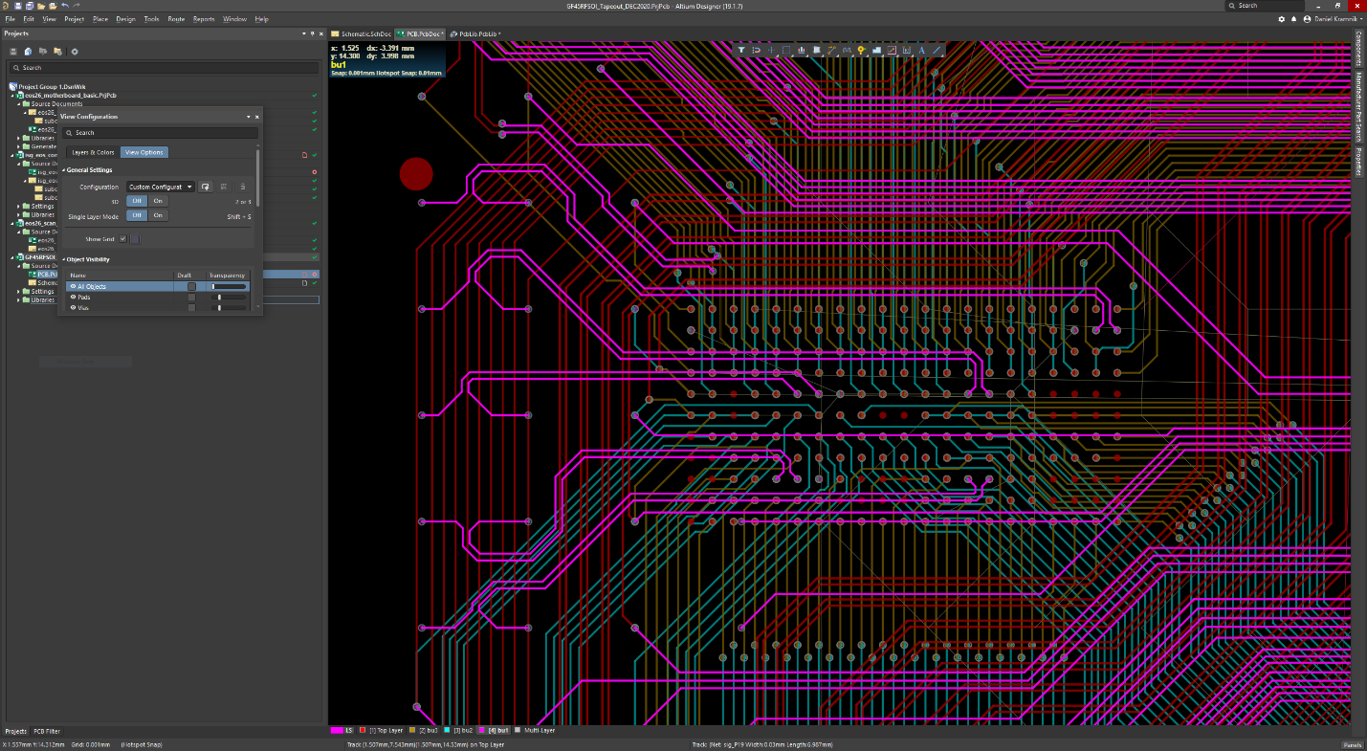

Recommend tying all NC bumps to GND so there are not floating metal bumps.

Pulse carver signals should follow diffpair naming convention (_P, _N) and be marked in the schematic with the diffpair symbol.